1.Which are the top three variables in your model which contribute most towards the probability of a lead getting converted?

Solution:

Based on the coefficient values from below screeshot, the following are the top three variables that contribute most towards the probability of a lead getting converted :

* Lead Source:
  + Positive Contribution:
  + Longer the visitor stays, likely to being converted
  + Sales team should focus on those leads
* Current Occupation Working Professional
  + Working Professinal seeking any certification course/ Skill upgradation is most likely to be converted
  + Budget Constraint is reduced
  + Higher conversion as a highly skilled Professional stands a better chance at converting a vacancy at one of the top MNC.
  + It would add to the huge base of the alumni of Company
* Last_Activity
  + The person whose last activity Includes Email Opened, Olark Chat Conversation, etc. can be contacted.

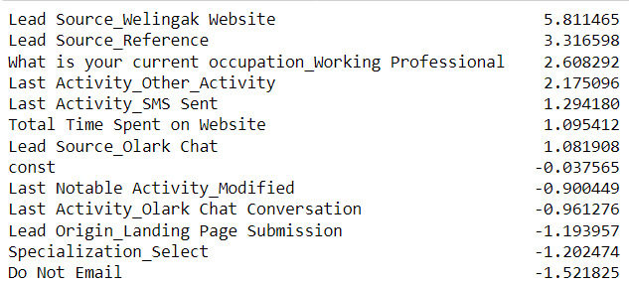

2.What are the top 3 categorical/dummy variables in the model which should be focused the most on in order to increase the probability of lead conversion?

Solution:



Again, based on the coefficient values from the screen shot in the question above, the following are the top three categorical/dummy variables that should be focused the most in order to increase the probability of lead conversion :

* Lead Source_Welingak Website
* Lead Source_Reference
* What is your current occupation_Working Professional

3. X Education has a period of 2 months every year during which they hire some interns. The sales team, in particular, has around 10 interns allotted to them. So during this phase, they wish to make the lead conversion more aggressive. So they want almost all of the potential leads (i.e. the customers who have been predicted as 1 by the model) to be converted and hence, want to make phone calls to as much of such people as possible. Suggest a good strategy they should employ at this stage.

Solution:

In the below image, the final prediction is calculated based on a optimal cut off value of

0.37.

In order to make the sales aggressive, the company may contact all the leads which have a conversion probabilty (value = 1) & the lead score greater than 80 %.Since, they have a high conversion rate.

Prospect Id’s having the highest Lead score more than 80% is providee below, who should be contacted.

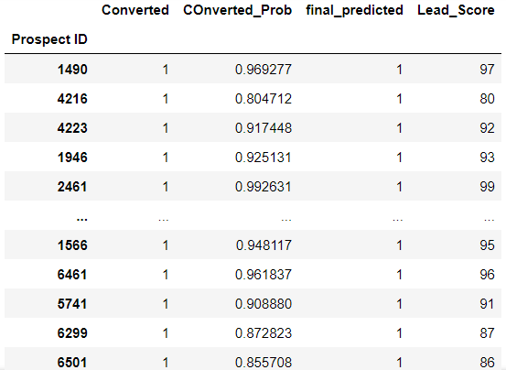

Phone calls should be made to:

* If the time spend on the website is more. To achieve this, the website should be made interesting, provding offers to the Working Professional/Students as they have high chances of getting converted.
* Last Activity is through SMS or Olark Chat
* Target leads which have come from the reference has high probablity of converting

4. Similarly, at times, the company reaches its target for a quarter before the deadline. During this time, the company wants the sales team to focus on some new work as well. So during this time, the company’s aim is to not make phone calls unless it’s extremely necessary, i.e. they want to minimize the rate of useless phone calls. Suggest a strategy they should employ at this stage.

Solution:

* Do not focus on unemployed leads. They might not have a budget to spend on the course .
* The company should not make calls to the leads whose lead origin is "Landing Page Submission" as they are NOT likely to get converted.
* The company should not make calls to the leads whose Specialization was "Others" as they are NOT likely to get converted.
* The company should not make calls to the leads who chose the option of "Do not Email" as "yes" as they are not likely to get converted.